Health And Education Amelioration For Rural Trust
(HEART)
Padalam, Madurantakam Tk, Chengalpattu Dist – 603 308,
Tamil Nadu, India

PROGRESS REPORT Annual 2019 - 2020

MANAGEMENT COMMITTEE  - Mr. K. Pandian  Managing Trustee  - Mr. C. Srinivasan  Financial Trustee  - Mrs. K. Sheela  Secretary  - Mrs. G. Rubalakshmi  Trustee  - Miss. S. Bhavani  Trustee  ADDRESS:  K Pandian  (Managing Trustee)  No.19, Big Street,  Padalam, Madurantakam Tk,  Chengalpattu Dist – 603 308  Tamil Nadu, India  Contact : +(91)- 9790518703  E-mail: hearttrust1@gmail.com  (Heart is registered under the Indian Trust Registration Act 1882 and registered under the 12AA & 80G.  Reg. number 40/2017) | MESSAGE FROM THE MANAGING TRUSTEE  Dear friends,  I am happy to present the activities of HEART TRUST for the past year. The information in this newsletter will demonstrate you that we have made considerable progress in a number of areas. HEART TRUST has been able to initiate a number of new programs in our villages. We are also getting growing recognition in the field of NGO’s. HEART TRUST has been visited by a number of officials from the government and funding agencies. In addition, a big honor has been bestowed upon HEART TRUST.  All these activities of HEART TRUST could not be successful without the moral and financial support of all our friends and well-wishers. I take this opportunity to thank all of them for their efforts. We hope that all of you will continue your support in the coming year. There is still much work to be done. Together we can continue our progress.  K.PANDIAN  (Managing Trustee, HEART TRUST)  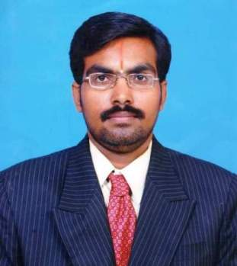
“ The road is long, let’s walk together,
The road is difficult, let’s help each other The road is the only one, let’s go in love The road opens before us, let’s start now”

Progress report:
Table of contents:
- Awareness programs
- Community Organization.
- Training programs.
- Institutional programs
- General activities

- Awareness programs.

Although people are generally becoming more aware of politics and the need for education, they are still ignorant in many specific areas, such as environmental and health-related issues, economics, and resource utilization and management. To aware them of these issues, HEART TRUST has conducted a number of camps and campaigns.

a). Environmental Awareness Campaign.

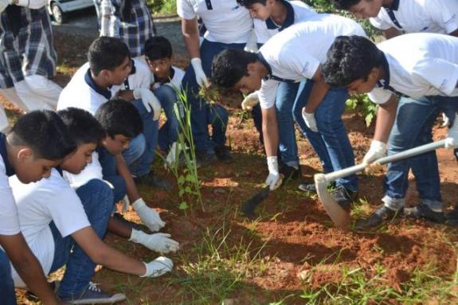
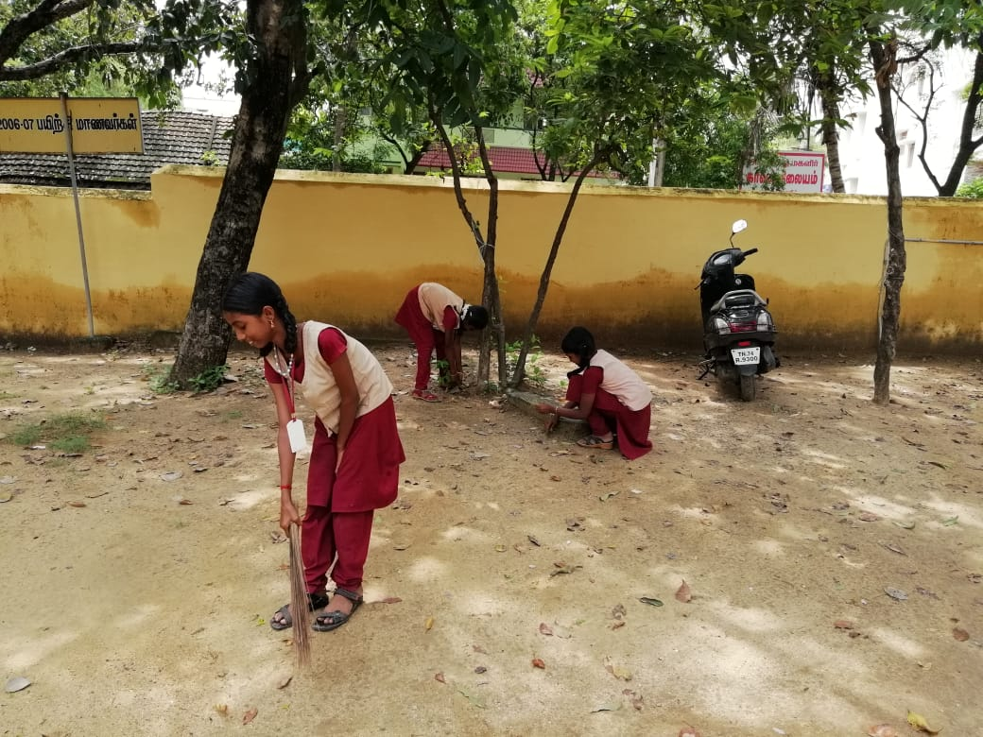
Our HEART TRUST has conducted three campaigns in the villages of Malaivaiyavoor, Nelli and Nelvoy on Feb 27, 28 and 29, 2020 on the topic “Save water”. In addition, on May 4, 5 and 7, 2020, HEART TRUST had previously conducted two campaigns on “Conservation and plantation for Environmental protection” in Padalam and Keelavalam. In each village, approximately 50 women, farmers and youth participated in each program. These programs had a big impact. As a follow-up, the people of Keelavalam have started to protect the collection points for drinking water, and they passed a resolution to keep the lake of their village pollution-free.

b). Women Awareness Generation Camp.

From February 22 through 26, 2020, HEART TRUST organized a Women Awareness Camp. A more detailed summary of the goals and accomplishments of this camp is presented on page 6.

HIV/AIDS Awareness To Rural Women.

Many rural people don’t know about HIV and AIDS. In poor rural families, the man usually migrates to nearby cities during the agricultural off- season for coolie work. There, some of them visit commercial sex workers, and contract STD’s which they pass on to their wives. Due to the increasing HIV/AIDS epidemic, these men have the risk of becoming HIV-infected. They transmit the HIV virus to their wives, who can pass the virus to their infants. Therefore, an HIV/AIDS awareness camp was conducted in 4 villages, for a total of 120 persons.

Child Health Care Awareness.

Because rural people have poor access to health-care institutions and medical advice, their health standards are very poor. In particular, insufficient attention is given to child health, as many infants don’t receive proper immunizations or medications against common diseases. This often leads to disability, or in some cases to premature death. For this purpose, a child health care campaign was conducted in 4 villages duringthe period June-September. A total of 108 women and mothers participated in this campaign.

Child Labor Eradication.

Children are precious, and they have the right to receive education, health-care, recreation and proper nutrition. But due to poverty, many children are forced into early employment in agriculture, silk weaving, etc., and they lose all their rights. To make people aware of the importance of early education for children, a child labor eradication seminar was conducted in 2 villages; 110 persons participated.

Consumer Awareness.

Many people are unaware of their rights as consumers, and are therefore often being exploited in many ways. Therefore, HEART TRUST organized a campaign jointly with the local consumer forum.

f). Health Awareness.

As mentioned previously, the level of health awareness among rural people is very low, due to lack of access to health care institutions and medical advice. Yet, health consciousness is vital for everybody. Hence, a camp was organized to inform people on proper nutrition and the prevention and cure of several common diseases. People were made aware of locally available resources and medical consultants, and were adviced not to neglect small health problems. This program was conducted in 3 villages, for a total of 163 participants.

Community Organization.

Women Self-Help Groups.

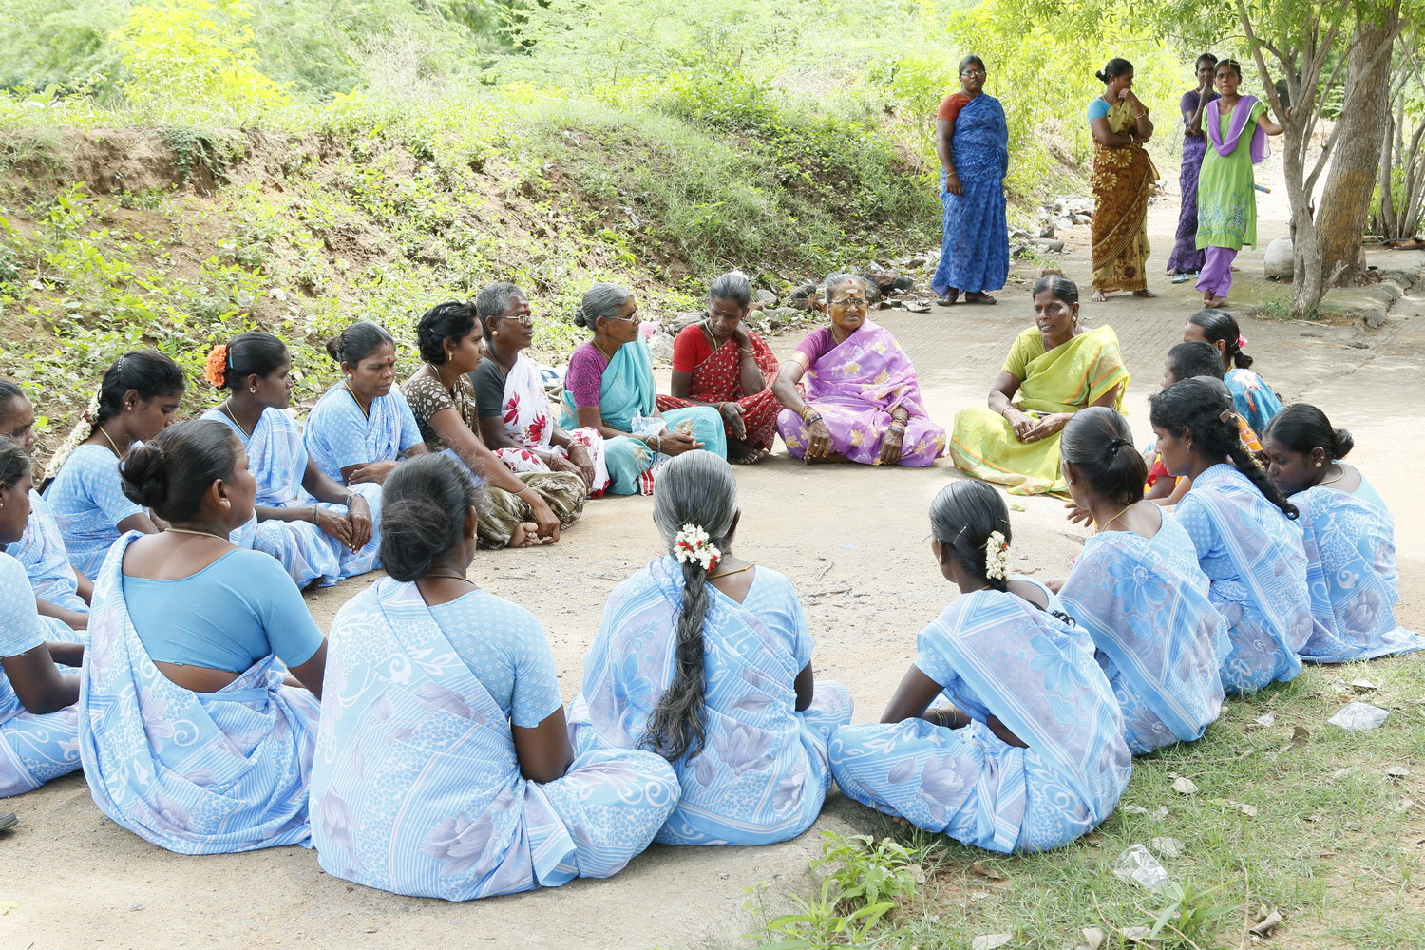
The “self-help” concept is becoming popular in our area thanks to our efforts in the past year. In addition to the 5 self-help groups that we had previously, this year, an additional 10 new self- help women groups have been promoted, each of them having savings and credit activities. This total of 15 women groups are now functioning in our area with the effort and guidance of HEART TRUST. For the 8 women groups in Puliparakoil, Arasarkoil, Pallipattu, and L.N.Puram, a revolving fund for a total amount of Rs.1,50,000 was mobilized from Development of Women and Children in Rural Areas. Each self-help group received Rs.30,000 to expand the credit activities which they had already formed from their own savings. This program is going very well. Thanks to this program, a total of 57 women has received credit to develop economic activities. Money is being used for a variety of purposes, such as the purchase of bullocks, sheep, poultry, goats, sewing machines.

Youth Movement.

This year, a youth movement was organized in Keelavalam with 15 juveniles, with the aim of using this group to activate community development. This group is now collaborating with respective officials of the government to develop their area with a proper road, a reading room facility, and a water facility.

Training programs.

Typewriting Program.

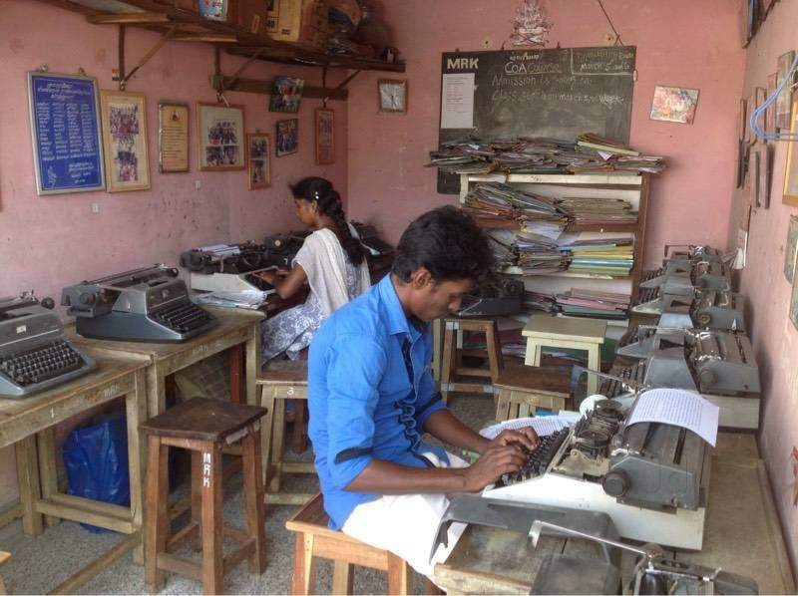
With the support of a grant from the Central Social Welfare Board, a vocational training program on type-writing and secretarial skills was conducted for 25 girls in HEART TRUST’s training center this year. At the end of the course, these trainees were sent for the government technical examination, and 4 girls passed this test;

Tailoring And Embroidery Program.

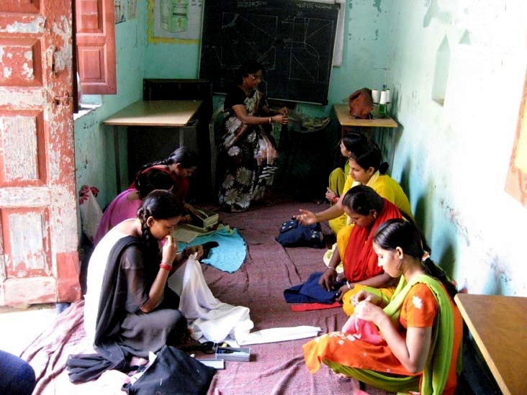
A paid training course on tailoring and embroidery is being given to 32 girls, to provide them with vocational skills for self-employment. Cutting, stitching, simple machine-sewing and garment production skills are being taught. This course is being offered every year.

c). Educational Aid.

HEART TRUST has provided educational tools, note- books, and stationary to the children in these above- mentioned schools: notebooks. This raises their interest in education, and reduces the educational and financial burden on their parents.

Computer Course.

HEART TRUST is proposing to offer a professional computer course to educate rural youth. Although this computer was originally provided for organizational and communication purposes to the HEART TRUST office, this computer will also be used for the course.

Women Awareness Generation Camp (February 22-26, 2020)

From February 22 to 26, 2020, HEART TRUST conducted a 5-day Women Awareness Camp at their building. A total of 25 women, ranging in age between 18 and 35 and coming from 5 different villages, participated in this program.
The main theme of the camp was ”Women are not subordinate creatures but they have their role in social development”.
Based on this main theme, a number of topics were presented by a number of speakers and discussed with the participants. In addition, the participants were also divided into 5 small groups of 5 members each, to discuss the women’s conditions and the problems. The following problems were identified during these discussions:
- Rural women are totally unaware and ignorant of happenings around them.
- The cultural, social and religious systems restrict women’s education, economic independance, and political and social participation.
- Male dominance is very common.
- Women are accustomed to subordination.
- Atrocities against women are very common, particularly sexual harrassment and assault.
- Education of girls is given little importance. Many girls are forced to drop out of school before they complete school education.
- Women are not organized.
- Women do not intend to get involved in economic and political activities.
- They seldomly use natural resources that are available in their village for their own development.
- They are unaware of governmental welfare programs that are designed for them.
- They are unaware of the concept of self-help programs.

To combat these problems in each of their villages, the participants have drawn an action plan to be implemented in the near future.
The Action Plan has the following principles:
- The women must get organized in their respective villages.
- The Self-help concept -Savings & Credit activity- has to be practised more intensively.
- Parents should be encouraged to allow their girls to study and at least complete school education.
- The girls who have already dropped out of school should be encouraged to complete their education through private studies.
- Villagers should meet frequently to discuss how to curb the unwanted cultural, social and religious restrictions on women’s education.
- We should voice against atrocities towards women.
- Women should make use of government welfare programs, particulary those aimed at the development of micro-enterprises.
- Women should participate in all village development and political activities.
- Everybody should work together to abolish female subordination and male dominance.
- Marriages of young girls should be restricted.

Epilogue:

We convey our gratitude to the Government Department, Panchayat Leaders, philanthropists, funding agencies, banks, our volunteer groups and sponsors for the success of our programmes. Next year we want to conduct more development work. Our future focus will also be to get funding assistance from foreign NGOs as well as Indian NGOs and Government agencies and serve the poor communities for a sustainable and equitable society.

*** %%% ***

